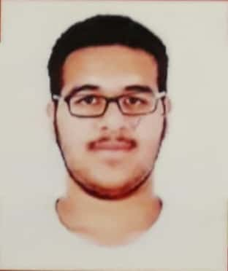

Mirza Abdulnabi Ali Ebrahim Mohammed

House no.:1239 B, Road no.:519, Block: 1205

Hamad Town- Kingdom of Bahrain

Mobile No. : 36969101

Email: [aldurazi528@gmail.com](mailto:aldurazi528@gmail.com)

Personal details:

Date of Birth: 03/02/1999

Place of Birth: jidhafs

Nationality: Bahraini

Material Status: Single

C.P.R No.: 990200701

Functions :

|  |  |
| --- | --- |
| 2013 | Middle East for spare parts company |

Experiences &Languages :

* Middle East spare parts company ( Four months - From 2013/July to 2013 October).
* Trainee In Hamad Town hospital.
* Certificate from INJAZ Bahrain.

1. Arabic 100% (Write/Read/Speak)
2. English 80% (Write/Read/Speak)

Skills / Activities:

* Computer programs
* Photography

